**HTC : Mumbai based brand  
METRAVI : Calcutta based brand  
FLUKE : International brand**

**HTC DM-97**[**http://www.urjakart.com/htc-dm-97-digital-multimeter.html**](http://www.urjakart.com/htc-dm-97-digital-multimeter.html) **Rs 1293**

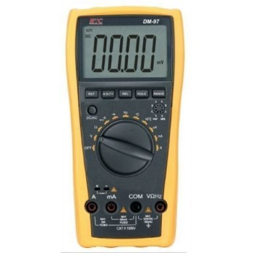

**Features:**

- 3¾ Digital Multimeter

- 4000 CountsLarge LCD Display with Auto/Manual Range

- No Power-OFF under natural operation

- Data Hold, Max. / Min. Value Hold

- Capacitance, Frequency / Duty Cycle

- Temperature and Transistor Test  
Specifications:

|  |  |  |
| --- | --- | --- |
| **Basic Functions** | **Range** | **Basic Accuracy** |
| DC Voltage | 0.1mV ~ 1000V | ±(0.5% + 4digit) |
| AC Voltage | 0.1mV ~ 750V | ±(0.8%+ 6digit) |
| DC Current | 0.1uA ~ 20A | ±(1.0% + 5digit) |
| AC Current | 0.1uA ~ 20A | ±(1.5% + 5digit) |
| Resistance | 0.1Ω ~ 40MΩ | ±(0.8% + 2digit) |
| Capacitance | 10pF ~ 200uF | ±(3.5% + 8digit) |
| Frequency | 0.1Hz ~ 30MHz | ±(0.5% + 4digit) |
| Celsius | -40oC～1000oC | ±(0.8% + 4digit) |
| hhFE (NPN or PNP) | 0 ~ 1000 |  |
| Dimension | 185x93x35 mm |  |

**Standard Accessories:**-Test Leads  
-Holster  
-Manual  
- TP 01 Temperature Probe Bead type

**HTC DM-88**

[**http://www.ebay.in/itm/HTC-3-Autoranging-Digit-Multimeter-Fluke-Looks-034-Multi-meter-tester-DM-88-/161323632477?_trksid=p2054897.l4275**](http://www.ebay.in/itm/HTC-3-Autoranging-Digit-Multimeter-Fluke-Looks-034-Multi-meter-tester-DM-88-/161323632477?_trksid=p2054897.l4275)

**Rs 1575**

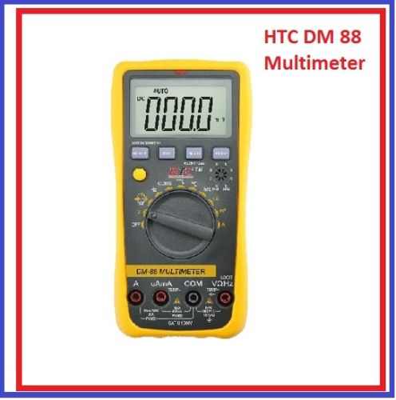

Features:

3¾ Digital Multimeter  
COMS, TTL Logic Test  
Large LCD display makes reading clear  
No Power-OFF under natural operation  
Data Hold, Max. / Min. Value Hold  
Capacitance, Frequency / Duty Cycle,Temperature and Transistor Test

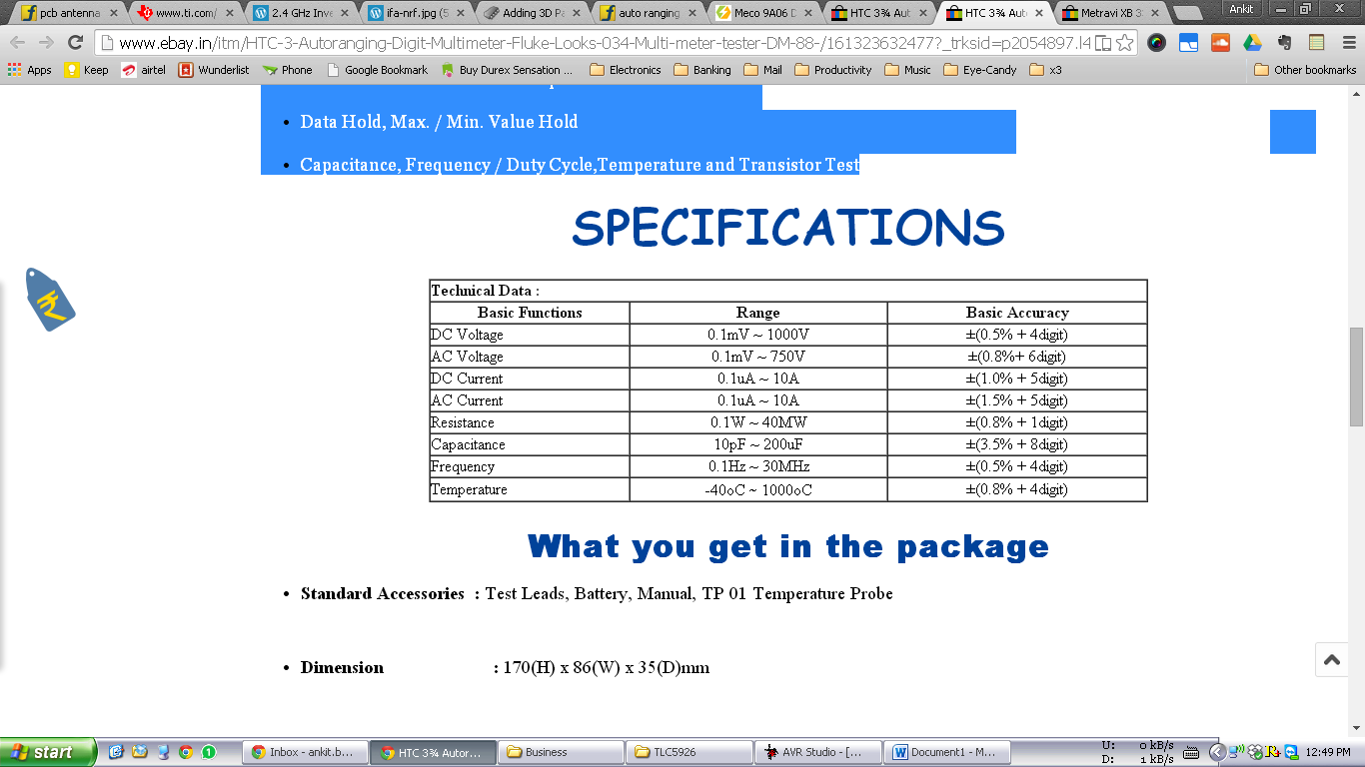

**HTC - 3½ Digit " Fluke Looks " Digital Multimeter Multi meter DM-86 tester**

<http://www.ebay.in/itm/HTC-3-Digit-Fluke-Looks-Digital-Multimeter-Multi-meter-DM-86-tester-/151432687325?_trksid=p2054897.l5660>

**Rs 1065**

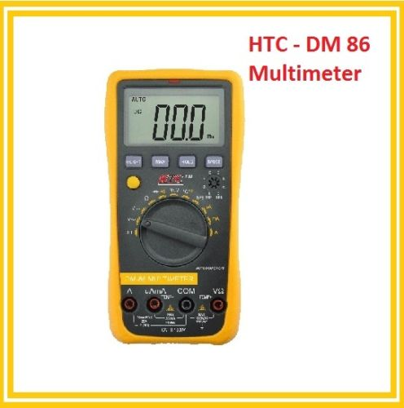

Features:  
  
3½ Digital Multimeter  
No Power-OFF under natural operation  
Full protection in All Ranges  
NCV Test

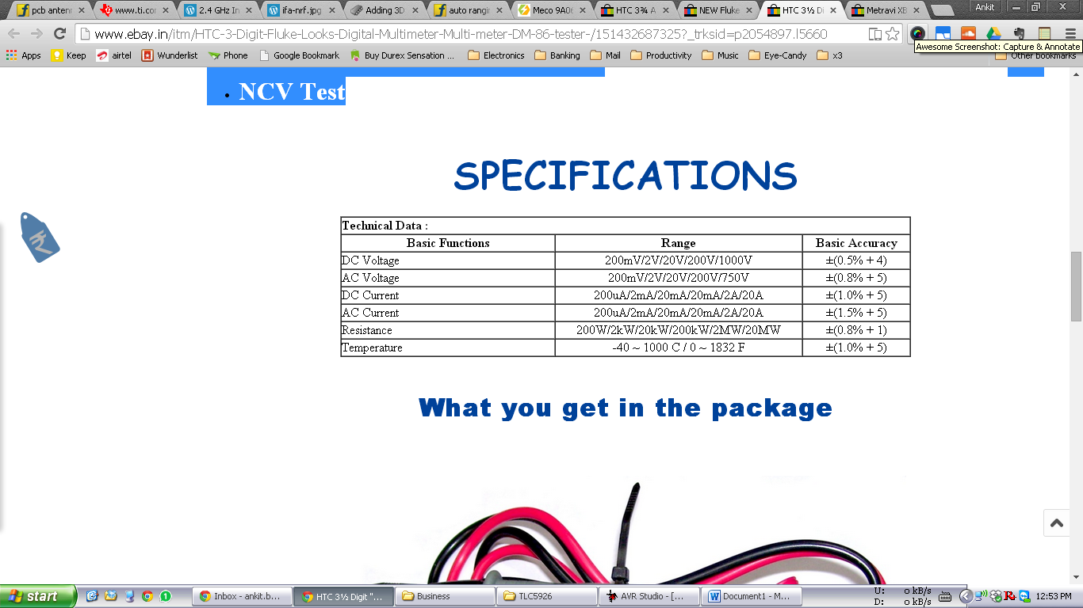

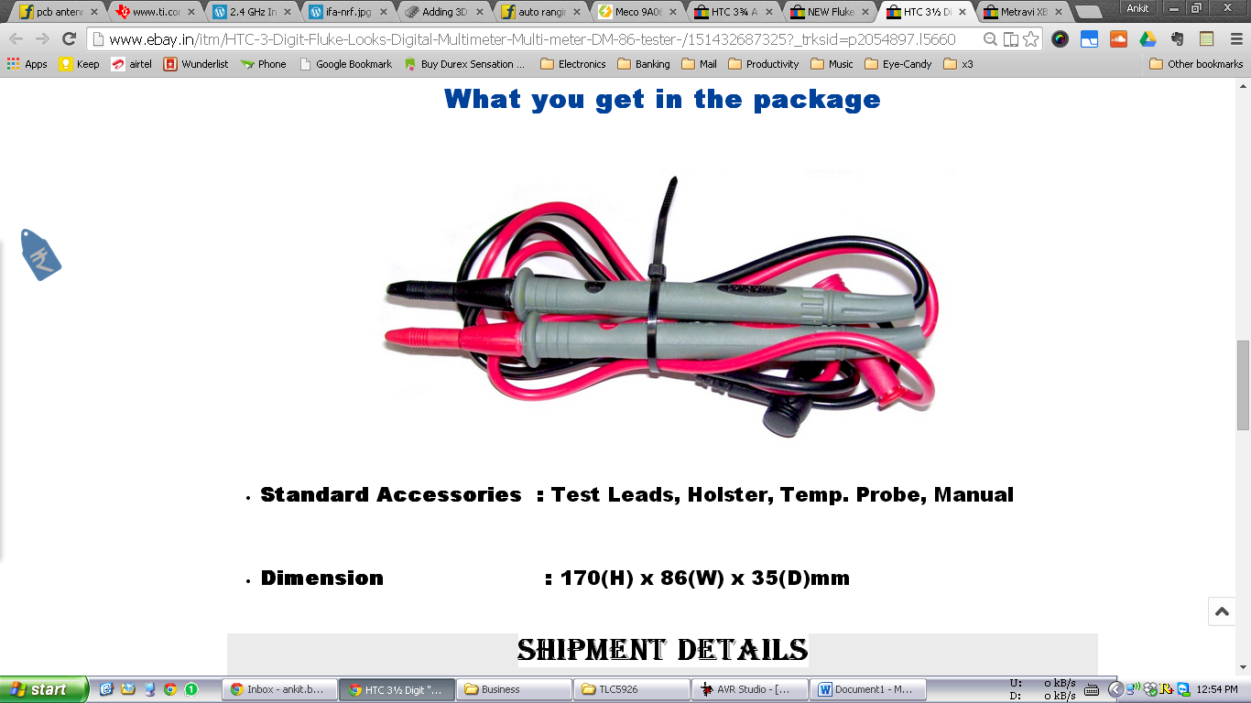

**New Fluke 101 Autoranging Digital Multimeter DMM**<http://www.ebay.in/itm/New-Fluke-101-Autoranging-Digital-Multimeter-DMM-/161454964722?_trksid=p2054897.l5659>

**Rs 2239**

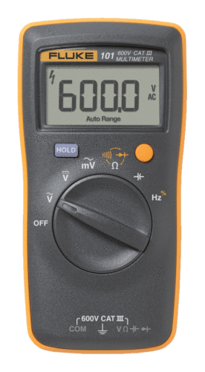

**Features**

|  |  |  |
| --- | --- | --- |
| |  |  | | --- | --- | | |  | | --- | | * Basic dc accuracy 0.5% * CAT III 600 V safety rated * Diode and continuity test with buzzer * Small lightweight design for one-handed use * Rugged, durable design * Automatic shutdown * Battery is easy to replace | | |

**Specification:**

|  |  |  |
| --- | --- | --- |
| **Electrical Specifications** | | |
| **V AC (40-500Hz)** | **Range** | 600.0 mV 6.000 V 60.00 V 600.0 V |
| **Resolution** | 0.1 mV 0.001 V 0.01 V 0.1 V |
| **Accuracy** | 3.0%±3 digit 1.0%±3 digit |
| **V DC** | **Range** | 6.000 V 60.00 V 600.0 V |
| **Resolution** | 0.001 V 0.01 V 0.1 V |
| **Accuracy** | 0.5%±3 digit |
| **Resistance Ohms** | **Range** | 400.0 Ω 4.000 kΩ 40.00 kΩ 400.0 kΩ 4.000 MΩ 40.00 MΩ |
| **Resolution** | 0.1 Ω 0.001 kΩ 0.01 kΩ 0.1 kΩ 0.001 MΩ 0.01 MΩ |
| **Accuracy** | 0.5 %±3 digit 0.5 %±2 digit 0.5 %±2 digit 0.5 %±2 digit 0.5 %±2 digit 1.5%±3 digit |
| **Capacitance** | **Range** | 50.00 nF 500.0 nF 5.000 μF 50.00 μF 100.0 μF |
| **Resolution** | 0.01 nF 0.1 nF 0.001 μF 0.01 μF 0.1 μF |
| **Frequency (10 Hz – 100 kHz)** | **Range** | 50.00 Hz 500.0 Hz 5.000 kHz 50.00 kHz 100.0 kHz |
| **Resolution** | 0.01 Hz 0.1 Hz 0.001 kHz 0.01 kHz 0.1 kHz |
| **Duty Cycle** | **Range** | 0.1 % to 99.9 % |
| **Resolution** | 0.1 % |
| **General Specifications** | | |
| **CAT Rating** | CAT III 600 V | |
| **V AC Range** | 600.0 V | |
| **V DC Range** | 600.0 V | |
| **Ohms Range** | 40.00 MΩ | |
| **Auto Shutoff** | Y | |
| **Continuity** | Y | |
| **Capacitor** | 100.0 μF | |
| **Frequency** | 100.0 kHz | |
| **Hold** | No | |
| **Duty Cycle** | Yes | |
| **Size** | 130 mm x 65 mm x 27mm | |
| **Weight** | 160 g | |
| **Battery** | Two AAA | |
| **Warranty** | 1 year | |
| **Environmental Specifications** | | |
| **Operating Temperature** | 0 °C to +40 °C | |
| **Storage Temperature** | -30 °C to +60 °C | |
| **Operating Humidity** | Non condensing (<10 °C) <=90% RH (at 10 °C to 30 °C) <=75% RH (at 30 °C to 40 °C) (Without Condensation) | |
| **Operating Humidity, 40 MΩ** | 80% RH 10 °C to 30 °C, 70% RH 30 °C to 40 °C | |
| **Operating Altitude** | 2,000 meters | |
| **Storage Altitude** | 12,000 meters | |
| **IP Rating** | IP 40 per IEC 60529 | |
| **Vibration Requirements** | MIL-PRF-28800F, Class 2 | |
| **Drop Test Requirements** | -10°C and 1 meter to surface, per IEC-61010-1, and Fluke SOP 39.1 for portable Hand-held equipment Shipping container drop per Fluke SOP 39. | |
| **EMI, RFI, EMC** | Must meet all applicable requirements in IEC/EN 61326-1 | |
| **Absorption/Corrosion** | Per Fluke SOP 39.1 | |
| **Temperature Coefficients** | Add 0.1 x specified accuracy for each degree C above 28 °C or below 18 ºC | |

**DM86**

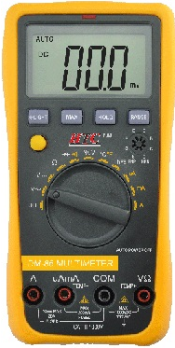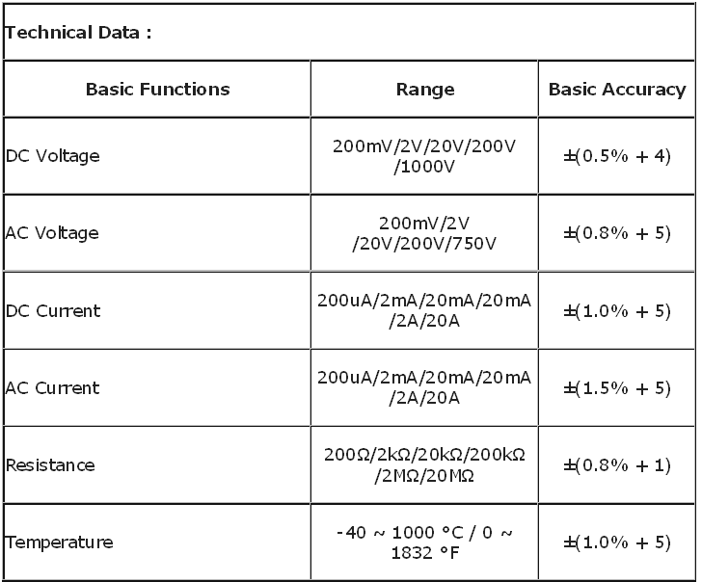

**DM87**

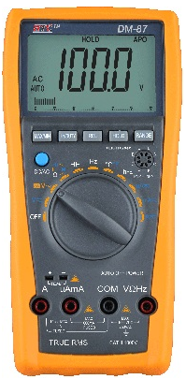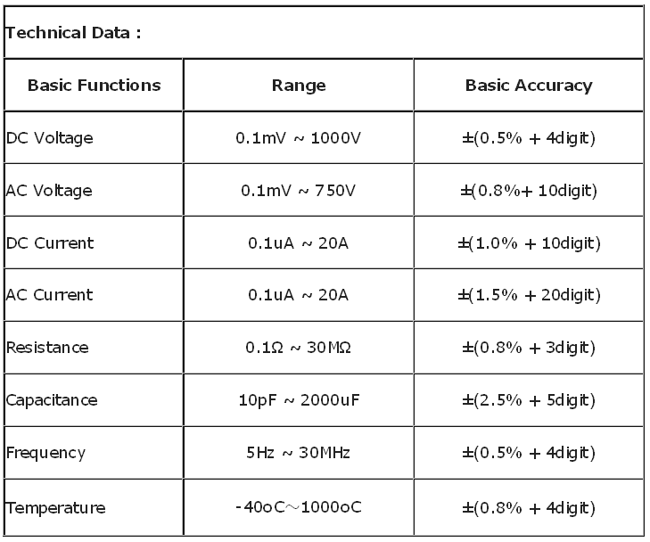

**DM88**

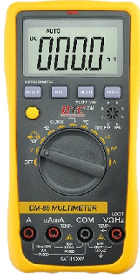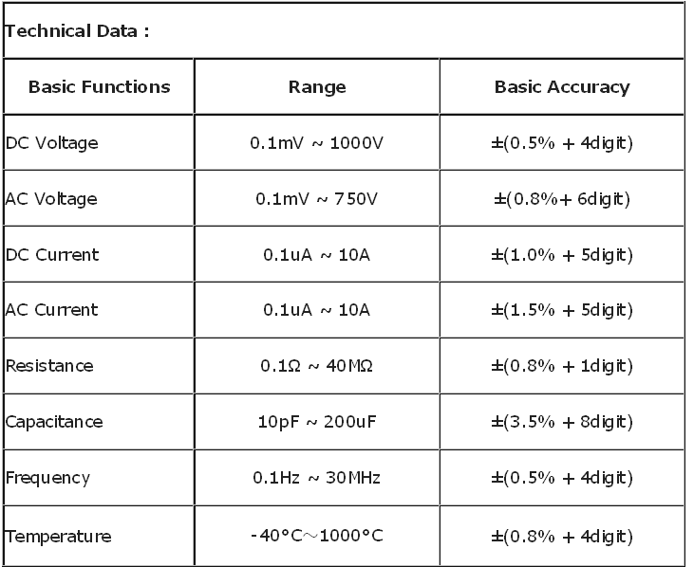

**DM 97**

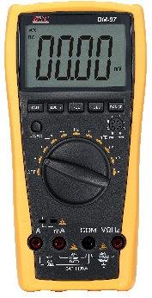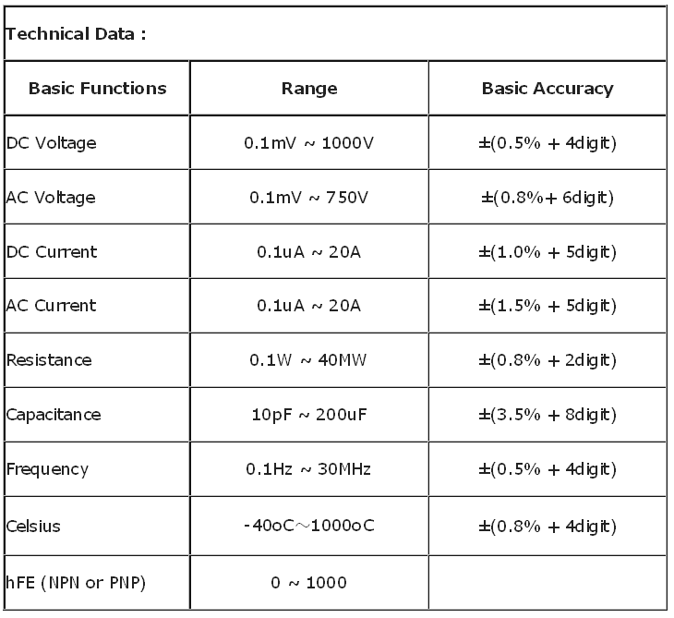

**DM98**

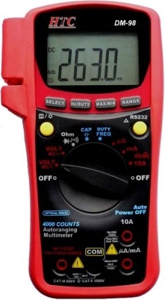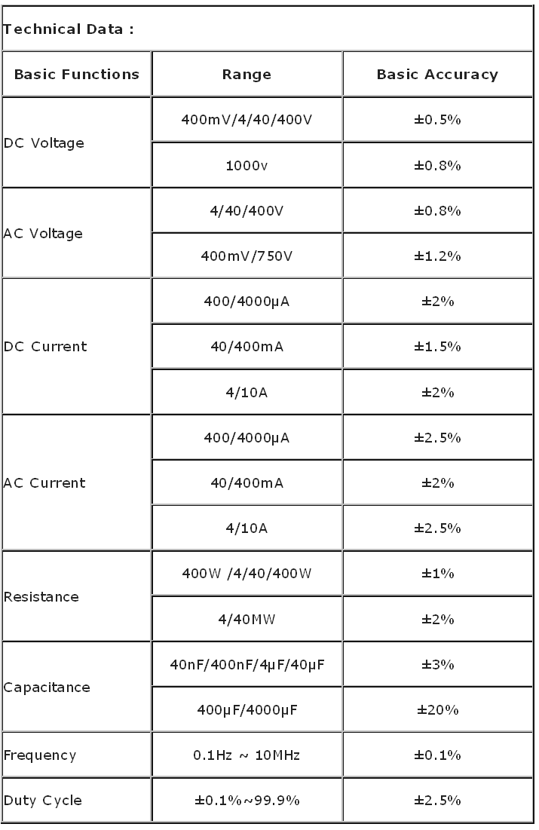

**UNI-T UT61E**

